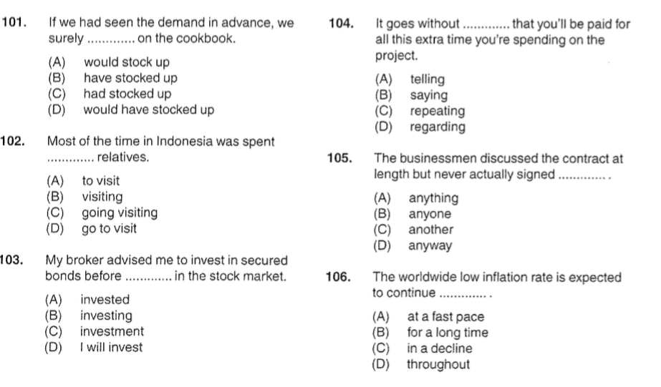

101. D

102.

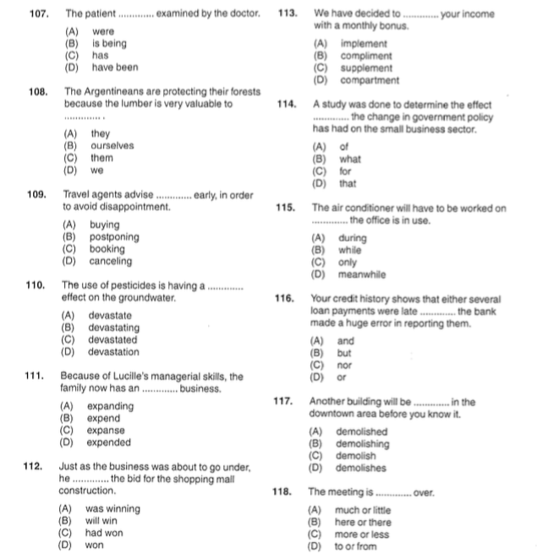

107. is being (B) 113. sipplement (C)

108. them (C) 114. that (D)

109. booking (C) 115. while (B)

110. devastating (B) 116. but (B)

111. expanding (A) 117. demolished (A)

112. won (D) 118. more or less (C)

